clear
clc
% Read in impulse response
fid = fopen('lpf_260_400_44100_80dB.bin','rb');
header = fread(fid,5,'int'); % Read in header
h = fread(fid,inf,'float'); % Read in impulse response
L = length(h);
fclose(fid);
% Read in input signal
[x,Fs] = audioread('fireflyintro.wav');
N = length(x);
% Convolve using custom convolution function
y = myconv(x,h);
M = N+L-1;
% Write out the audio signal
audiowrite('fireflyintro_output.wav',y,Fs);
% Visualize the filter impulse response
figure();
plot([0:L-1],h,'LineWidth',2);
xlabel('Sample Index');
ylabel('Amplitude');
title('Impulse Response');
grid on;
shg;
print -dpng impulse_response.png
% Visualize the filter frequency response
NFFT = 2^14;
F = Fs * ([0:NFFT-1]/NFFT - 0.5); % Frequency vector [Hertz]
H = fftshift(fft(h,NFFT)); % Compute Fourier transform
figure();
plot(F,20*log10(abs(H)),'LineWidth',2); % Plot magnitude response in dB
axis([0, 1200, -100, 10]); % Set axis limits
xlabel('Frequency [Hertz]');
ylabel('Magnitude [dB]');
title('Frequency Response');
grid on;
shg;
print -dpng magnitude_response.png
% Visualize signals in time domain
figure();
t = [0:N-1]/Fs; % Time vector [seconds]
plot(t,x); hold on;
t = [0:M-1]/Fs; % Time vector [seconds]
plot(t,y); hold off;
xlabel('Time [seconds]');
ylabel('Amplitude');
legend('Input x[n]','Output y[n]');
title('Input & Output Signals');
grid on;
shg;
print -dpng audio_timedomain.png
% Plot spectrograms of input and output signals
figure();
subplot(211);
[S,F,T] = spectrogram(x,hamming(NFFT),round(0.9*NFFT),NFFT,Fs);
imagesc(T,F,20*log10(abs(S)),[0 50]);
colorbar;
set(gca,'YDir','normal');
ylim([0 1500]);
xlabel('Time [seconds]');
ylabel('Frequency [Hertz]');
title('Spectrogram of the Input x[n]');
grid on;
subplot(212);
[S,F,T] = spectrogram(y,hamming(NFFT),round(0.9*NFFT),NFFT,Fs);
imagesc(T,F,20*log10(abs(S)),[0 50]);
colorbar;
set(gca,'YDir','normal');
ylim([0 1500]);
xlabel('Time [seconds]');
ylabel('Frequency [Hertz]');
title('Spectrogram of the Output y[n]');
grid on;
shg;
orient tall;
print -dpng audio_spectrograms.png
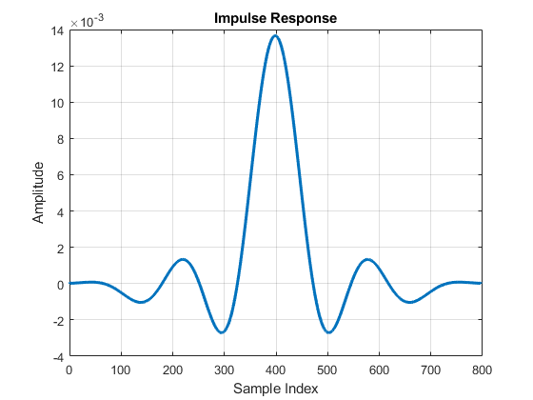
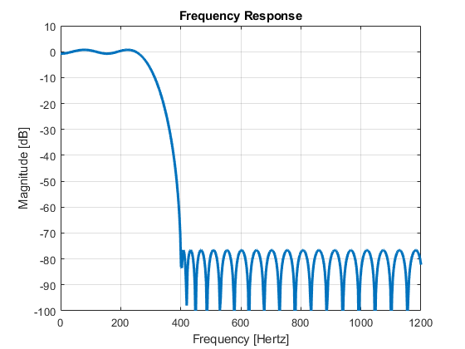
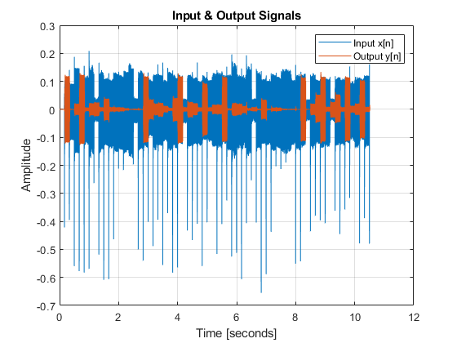
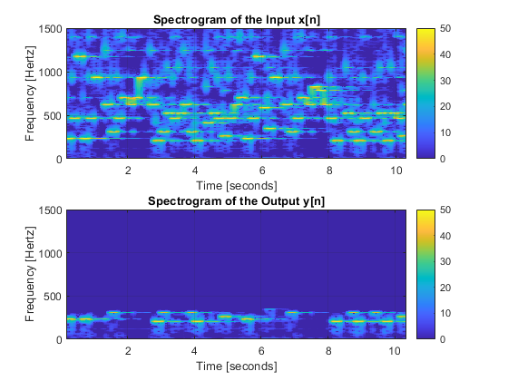
Published with MATLAB® R2023a

